GCP project
Customer-data-pipeline
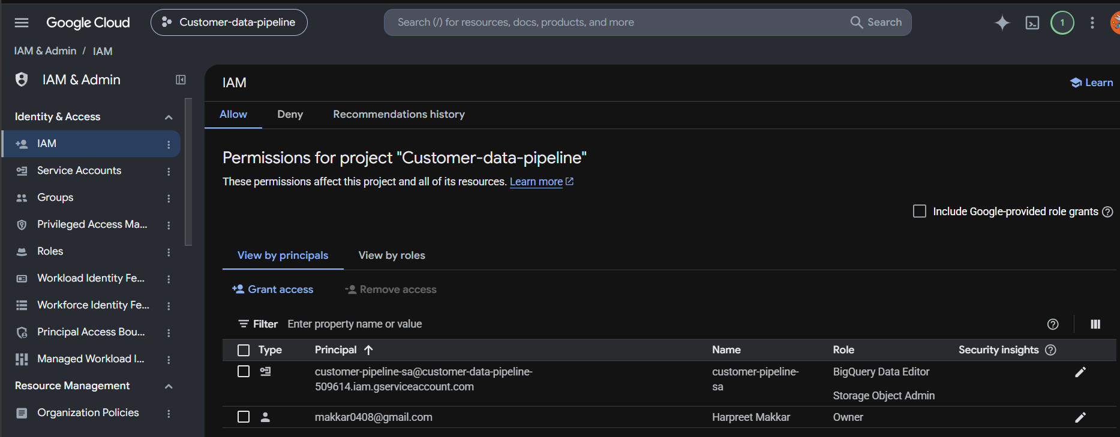

GCP Cloud Storage
The bucket – customer-data-bucket-123
The file customer_dataset_cleaned.csv was received by python program
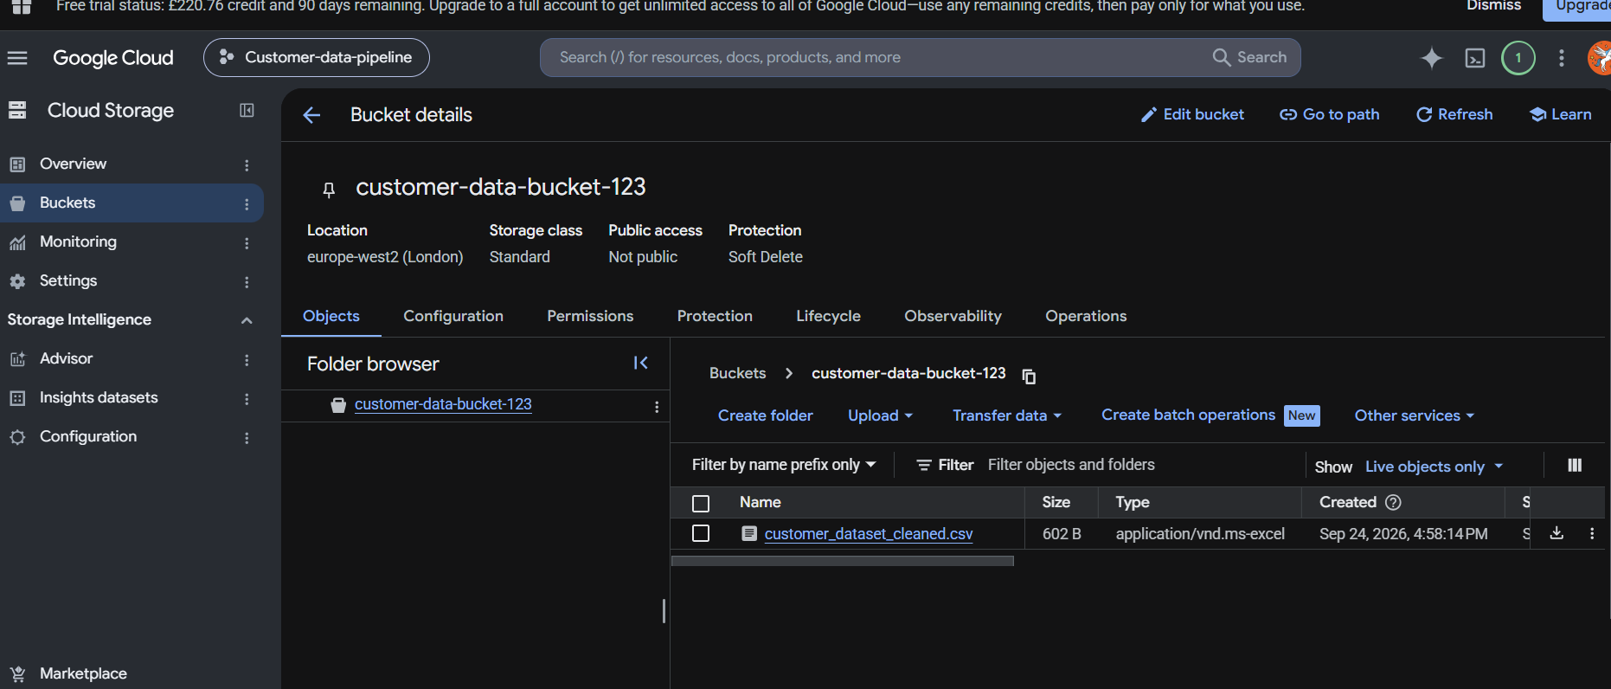

The service account(customer-pipeline-sa) was created with below permissions to connect to python SDK
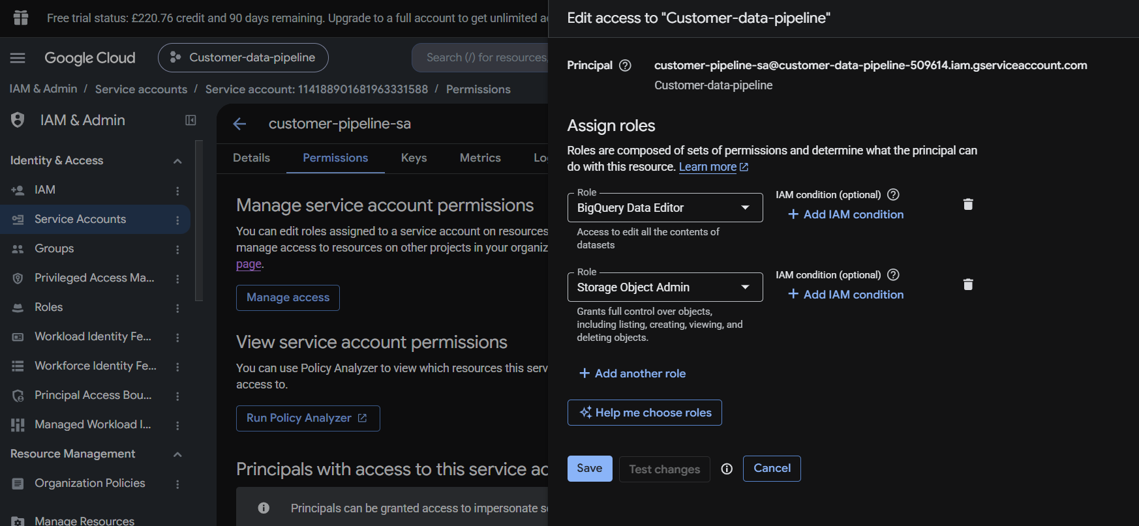

The dataset(customer_data_odp) and further table(customer_orders) was created directly from GCS using upload as below
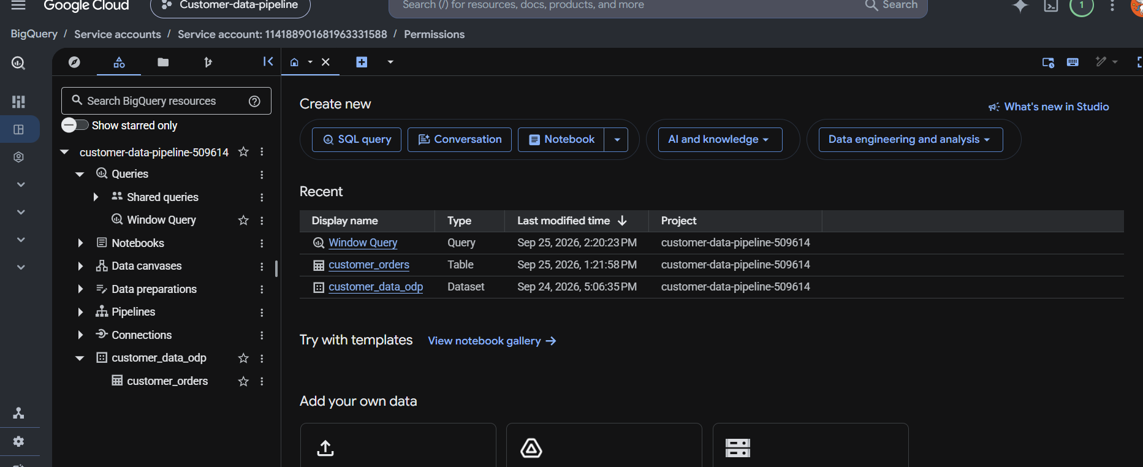

Both the queries as below
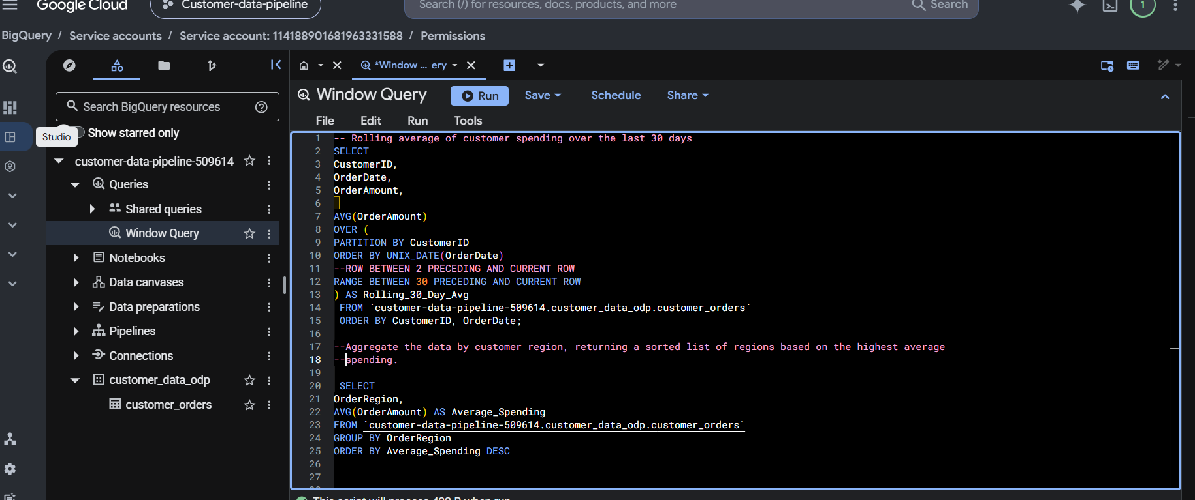

Results of 1st Rolling average window query
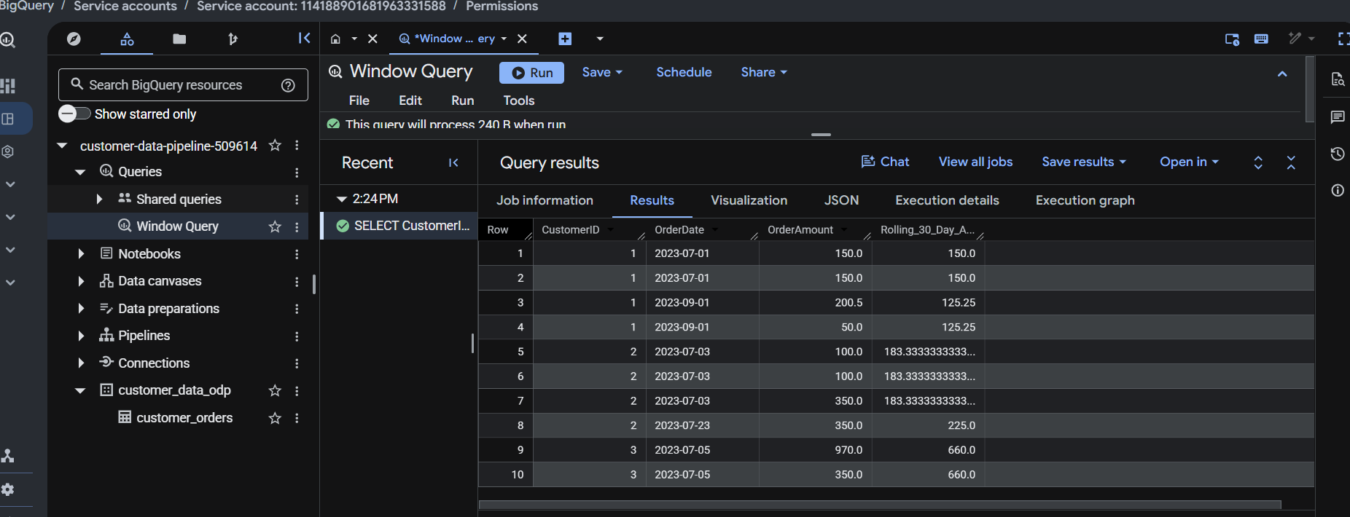

Results of aggregate by region query
